Quantum Secure Email Client Application

Computer networks allows us to send data from one machine to other machine which are at different places and can be used to send and receive secret messages but sometime some malicious users can intercept communication to steal secret data. To overcome from data stealing many encryption algorithms are designed but those algorithms will encrypt data using traditional Key Generation scheme which can be hack by genius hacker very easily. Many famous encryption algorithms such as AES, RSA, triple des and many more are using traditional key generation system.

Now we are moving from traditional computing power to quantum computing power which is a multidisciplinary field comprising aspects of computer science, physics, and mathematics that utilizes quantum mechanics to solve complex problems faster than on classical computers. Using quantum computing we can generate high secured key for traditional encryption algorithms which cannot be break in any format. Research proof that Keys generated using quantum computing can take millions of years to get break. So we are migrating EMAIL system to use Quantum generated keys for messages and attachments encryption.

Quantum computing keys generation and distribution consists of two task

Qubit computation: In quantum computing, a qubit is a quantum bit, which is the fundamental unit of information. A qubit is a 2-state quantum system that can be in a superposition state of 0 and 1 at the same time.

Basis Measurement. A measurement basis in quantum computing is a specific basis, such as the computational basis, that is used to perform a quantum measurement. The computational basis is represented by the states ∣0⟩ and ∣1⟩.

Creating and distributing keys using above computation can be difficult to crack and in below screen we are showing code to generate keys using quantum computing

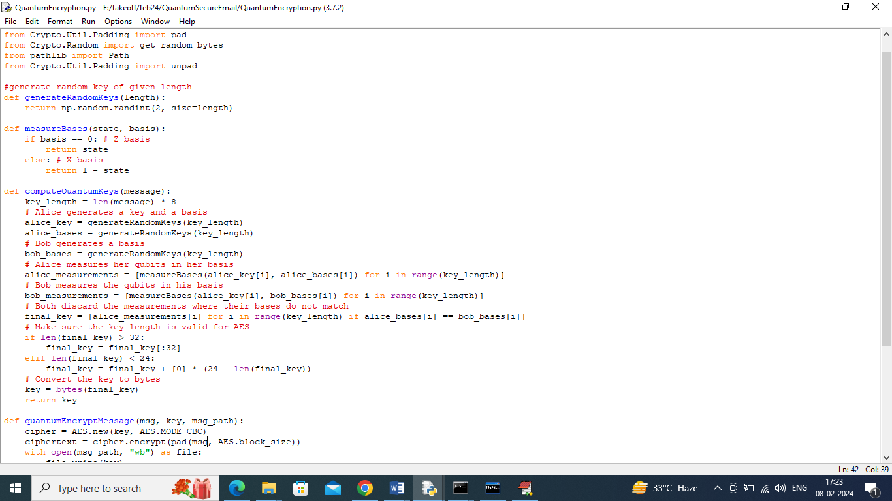

In above screen read red colour comments to know about quantum key generation and measurement between two users Alice and Bob. While generation we are measuring key strength by employing Qubit and Basis technique.

To implement this project we have designed following modules

1. User Sign up: using this module user can sign up with the application
2. User Login: can be used to login to systems
3. Compose Mails: after login sender can select desired receiver to send mails and while sending application will apply quantum computing to generate keys and to encrypt messages and then send to receiver account
4. View Mails: receiver can view list of mails and then can click on ‘Decrypt Message’ link to decrypt and view messages. Can click on download file to decrypt and download attachment file.

To run project install python 3.7 and then install all packages given in requirements.txt file and then install MYSQL software and then copy content from DB.txt and paste in MYSQL console to create database.

SCREEN SHOTS

To run project double click on ‘run.bat’ file to get below screen

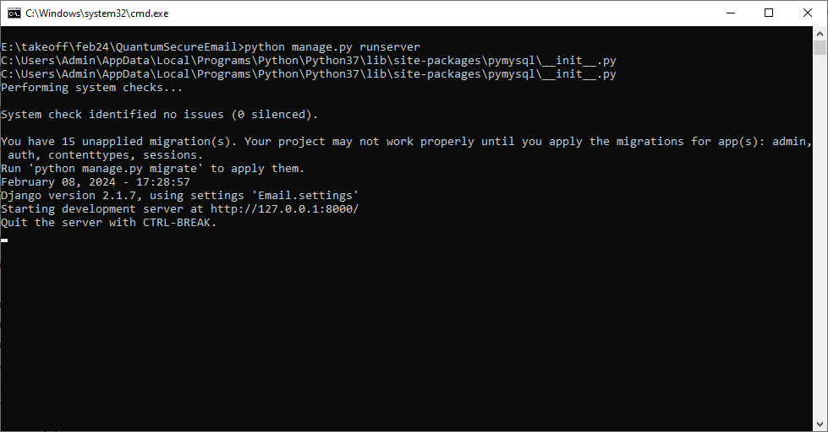

In above screen python server started and now open browser and enter URL as <http://127.0.0.1:8000/index.html> and press enter key to get below page

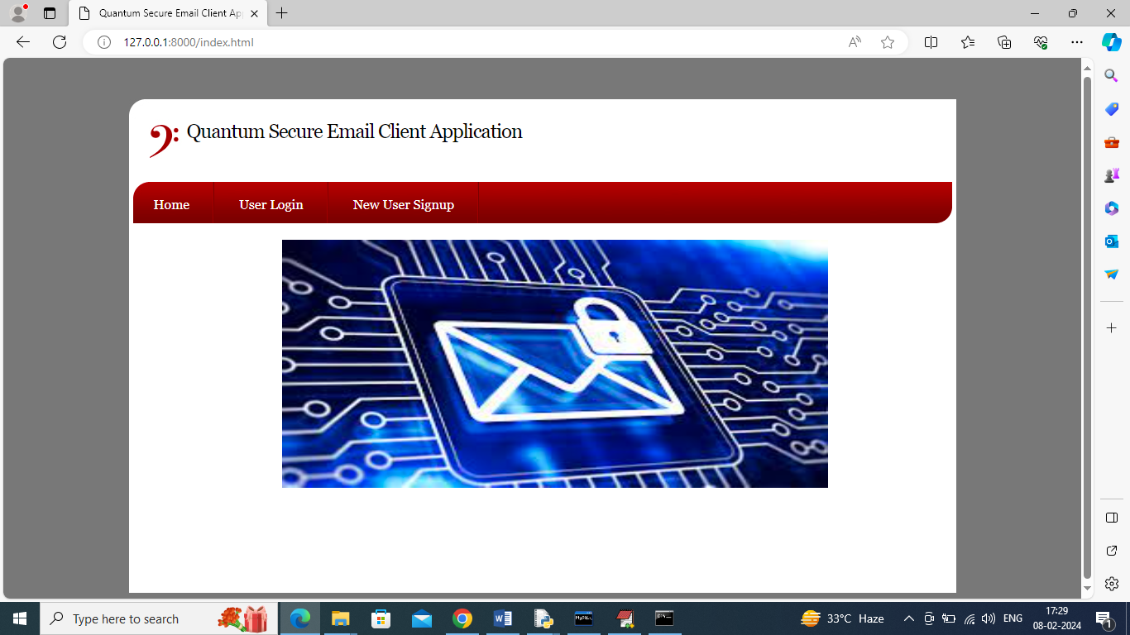

In above screen click on ‘New User Sign up’ link to get below page

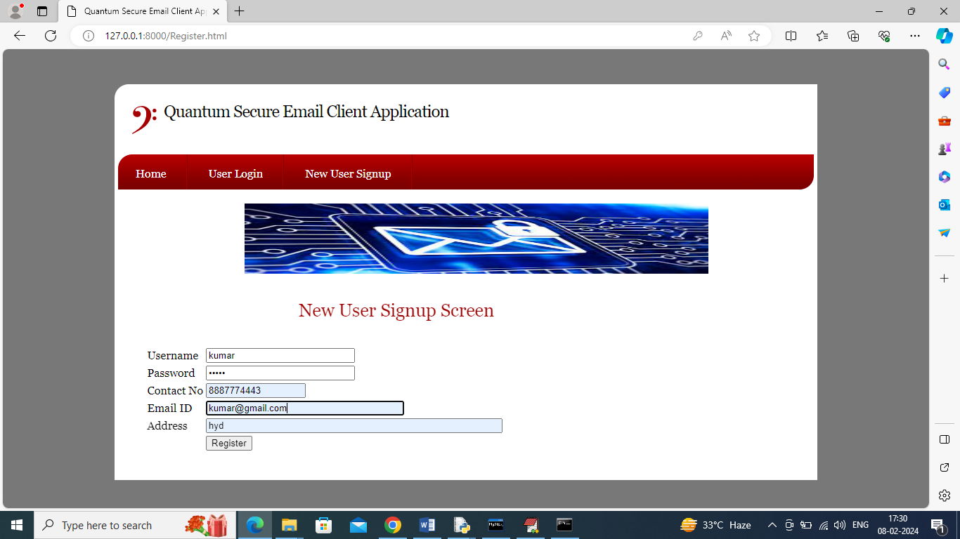

In above screen user is entering sign up details and then click on ‘Register’ button to complete sign up and get below output

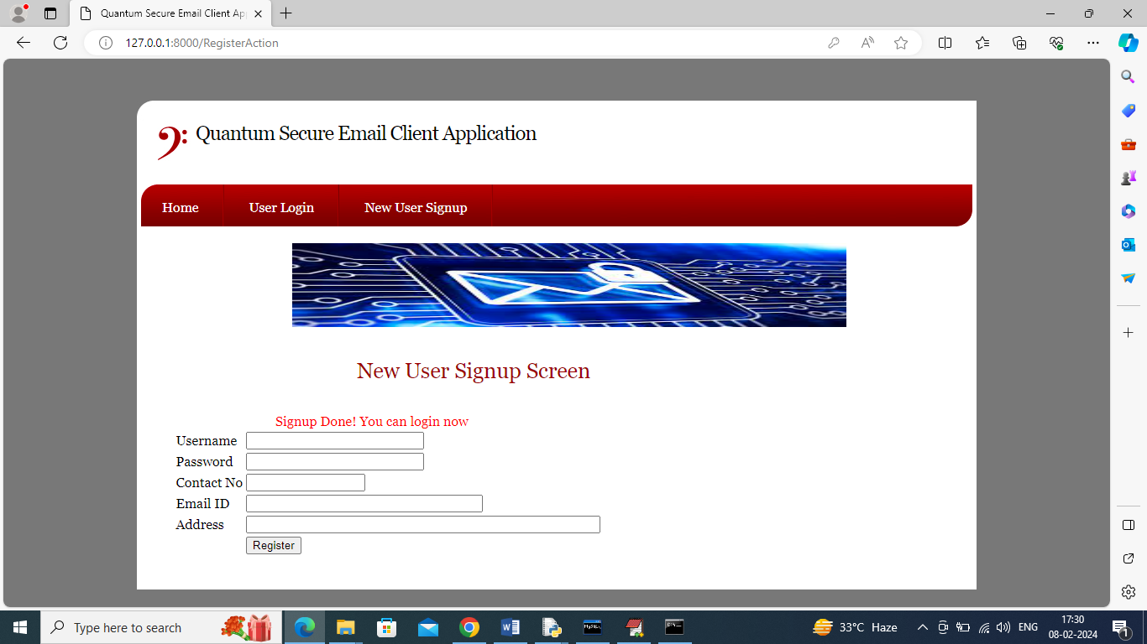

In above screen sign up completed and similarly you can add any number of users and now click on ‘User Login’ link to get below page

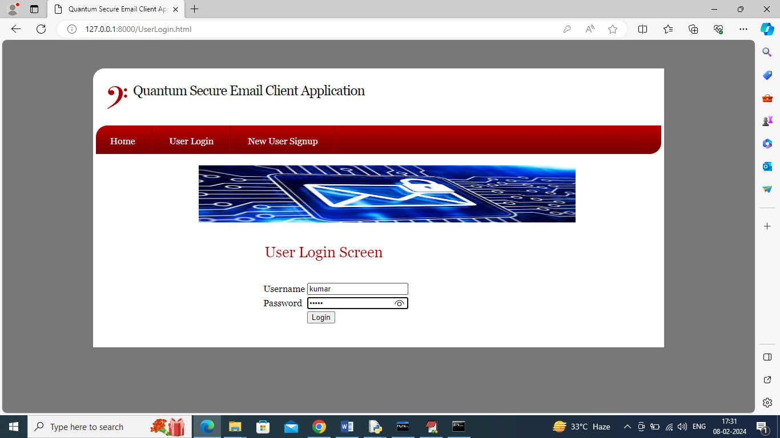

In above screen user is login and after login will get below page

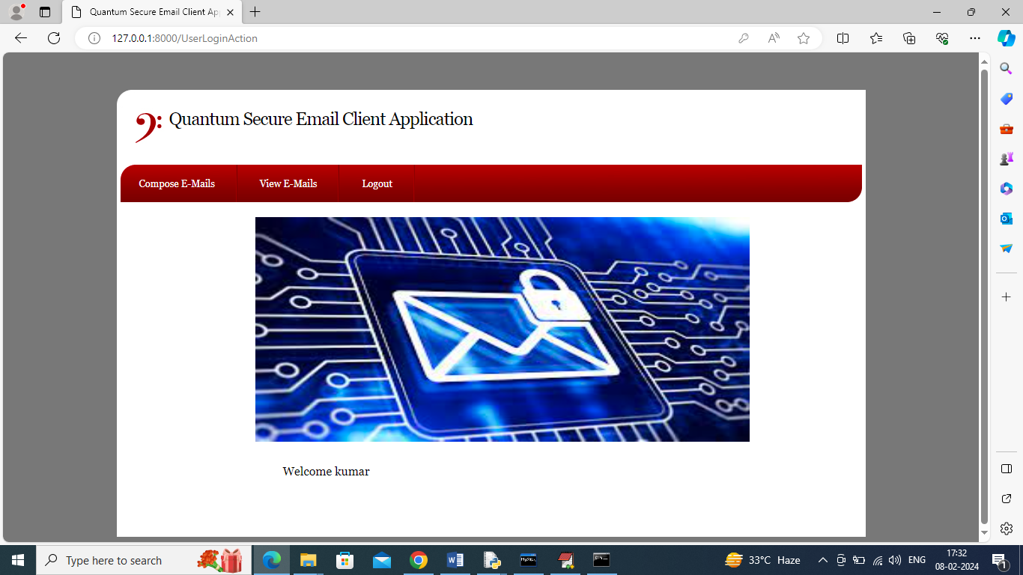

In above screen user can click on ‘Compose E-Mails’ link to get below page

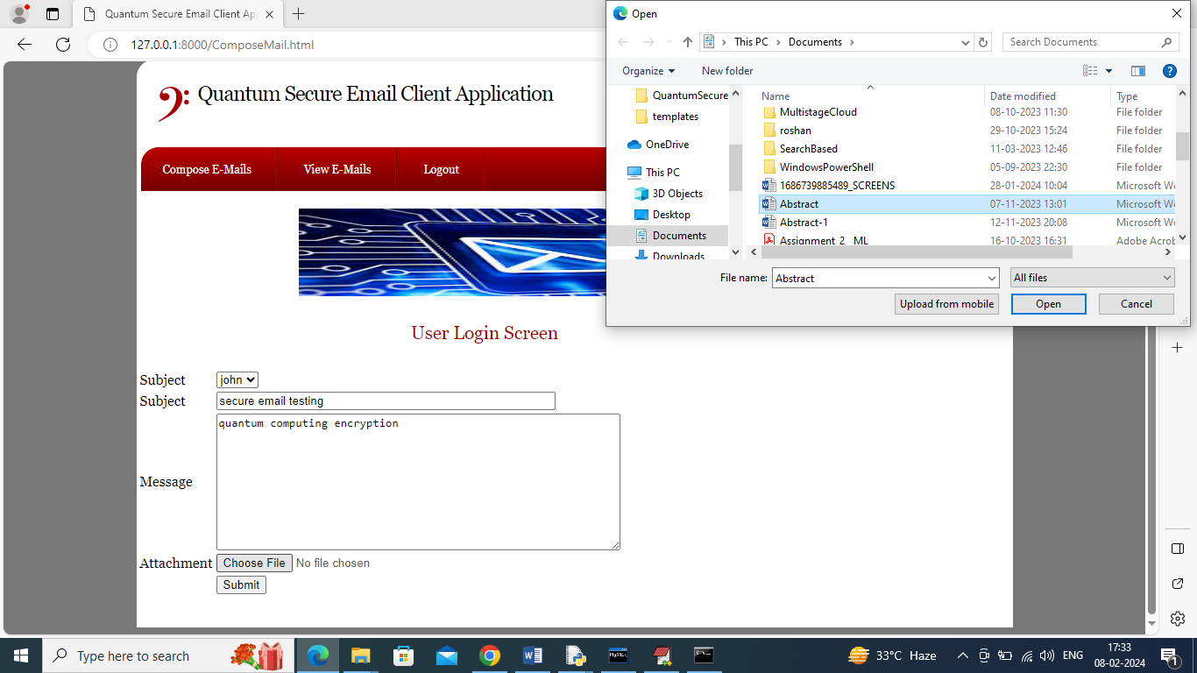

In above screen user is selecting receiver from drop down box as John and then entering some message and then uploading some attachment file and then click on ‘Submit’ button to encrypt and send mails and then will get below output

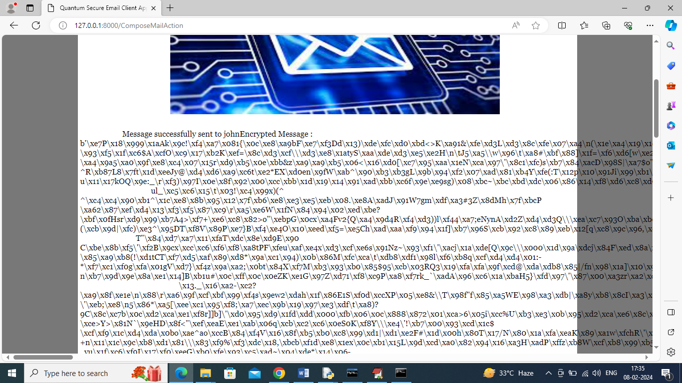

In above screen can see message sent to receiver and can see encrypted message details and from above encrypted message no one can understand or hack as its fully too complex to understand. Now logout and login as john to view mails

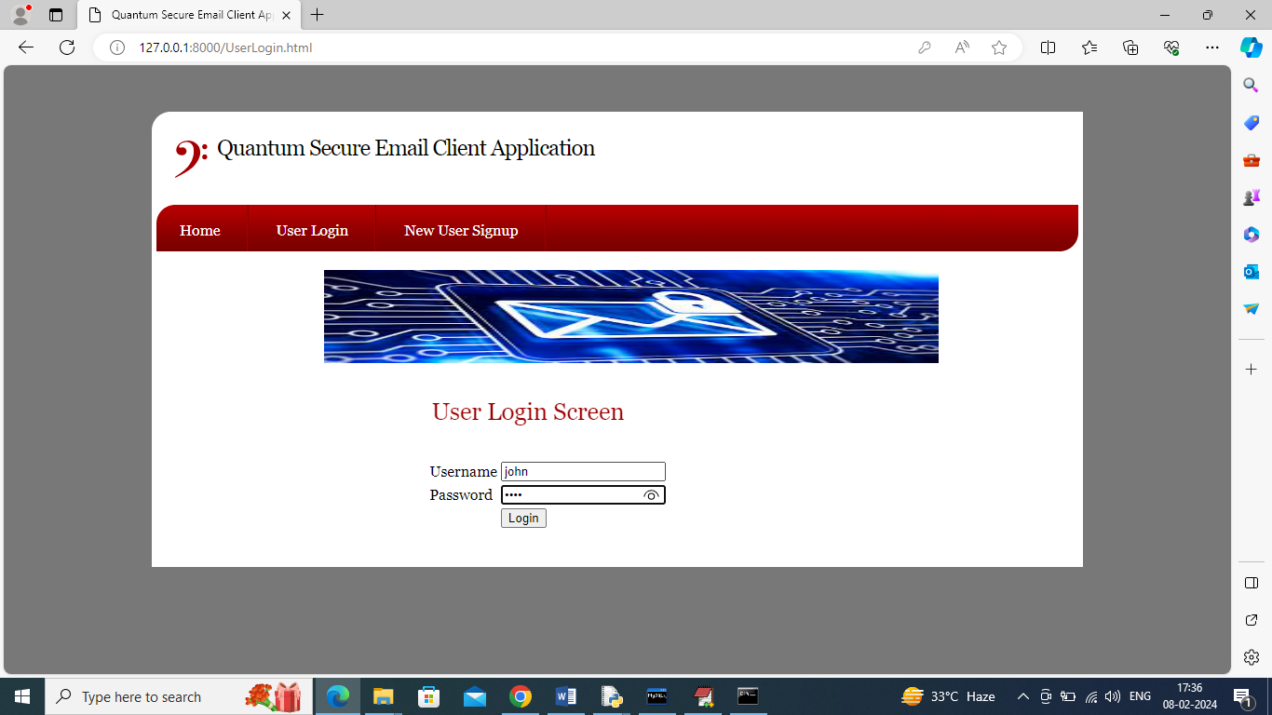

In above screen receiver user is login and after login will get below page

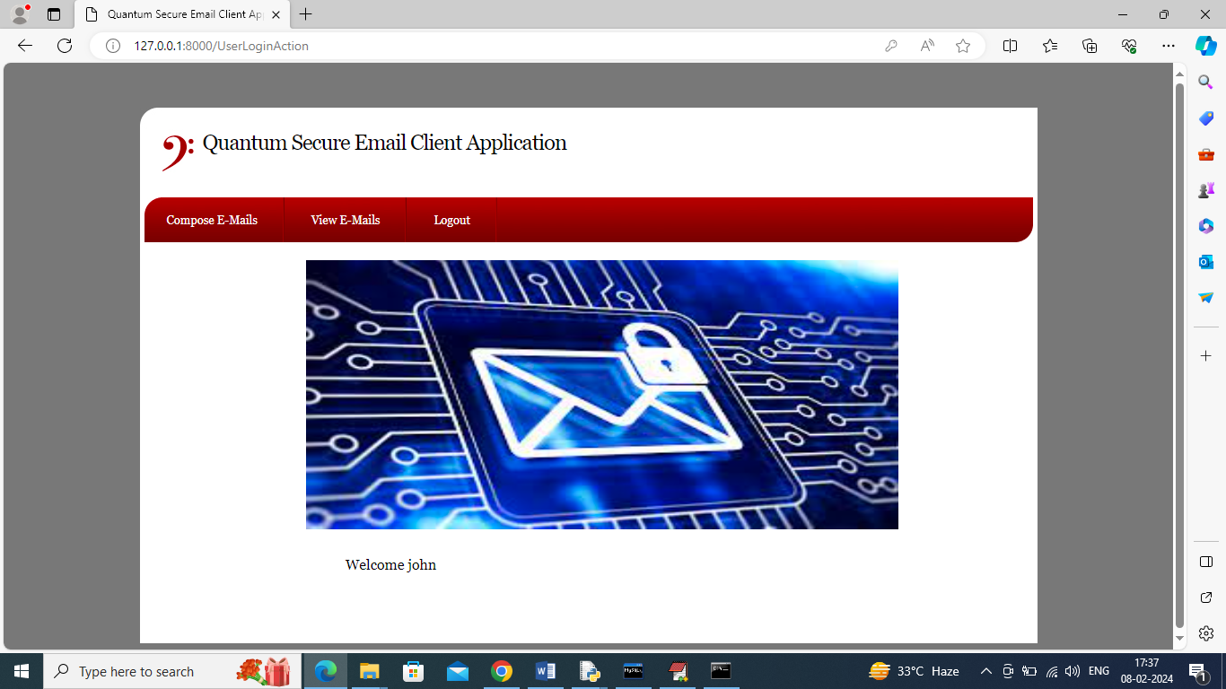

In above screen click on ‘View Mails’ link to view list of emails like below page

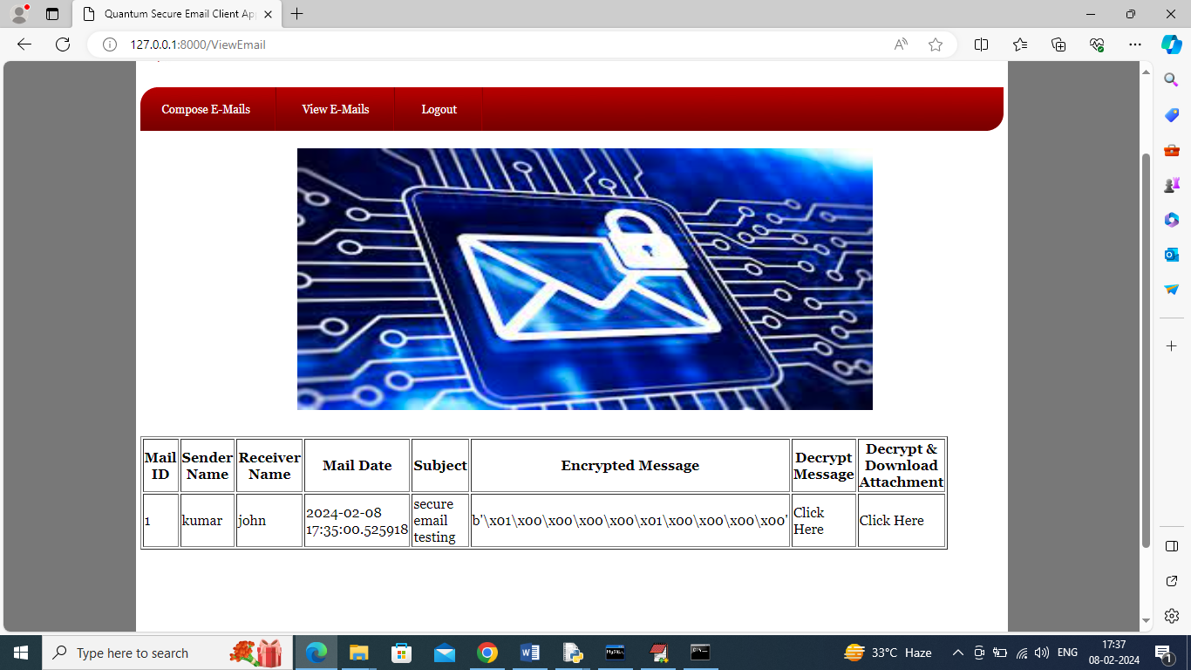

In above screen receiver can view sender name and subject but message is in encrypted format and to view message click on first ‘Click Here’ link and then will get below output

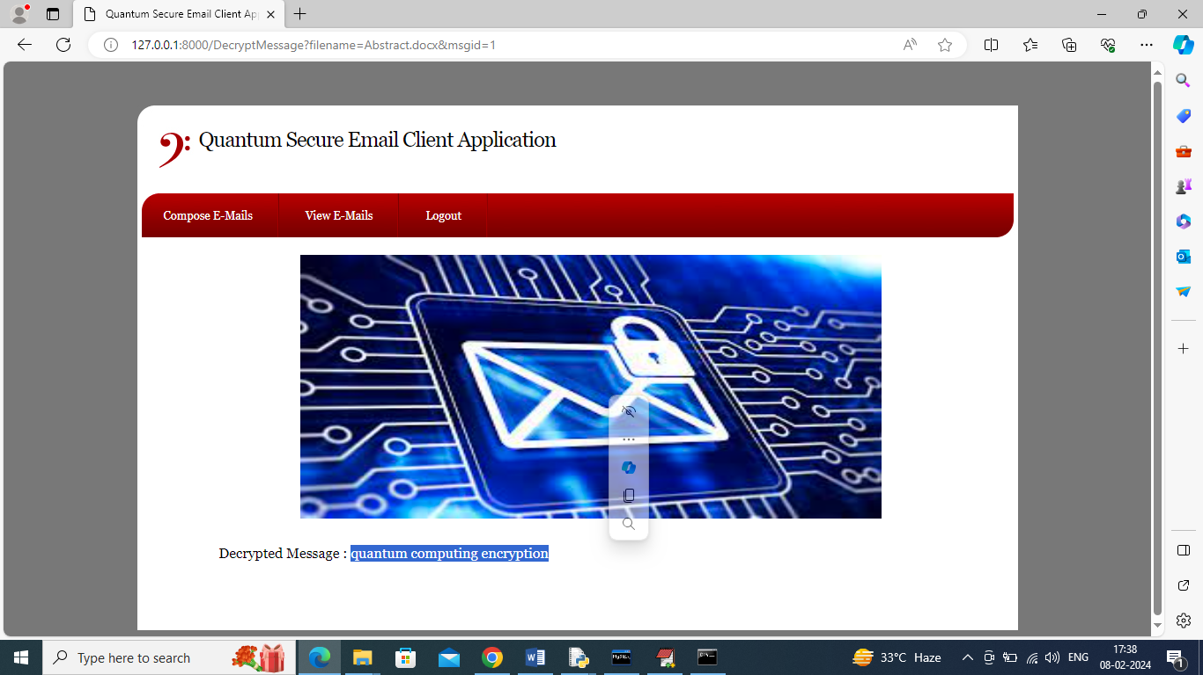

In above screen can view decrypted message and now re-click ‘View Mails’ link and then click on second ‘Click Here’ link to decrypt attachment

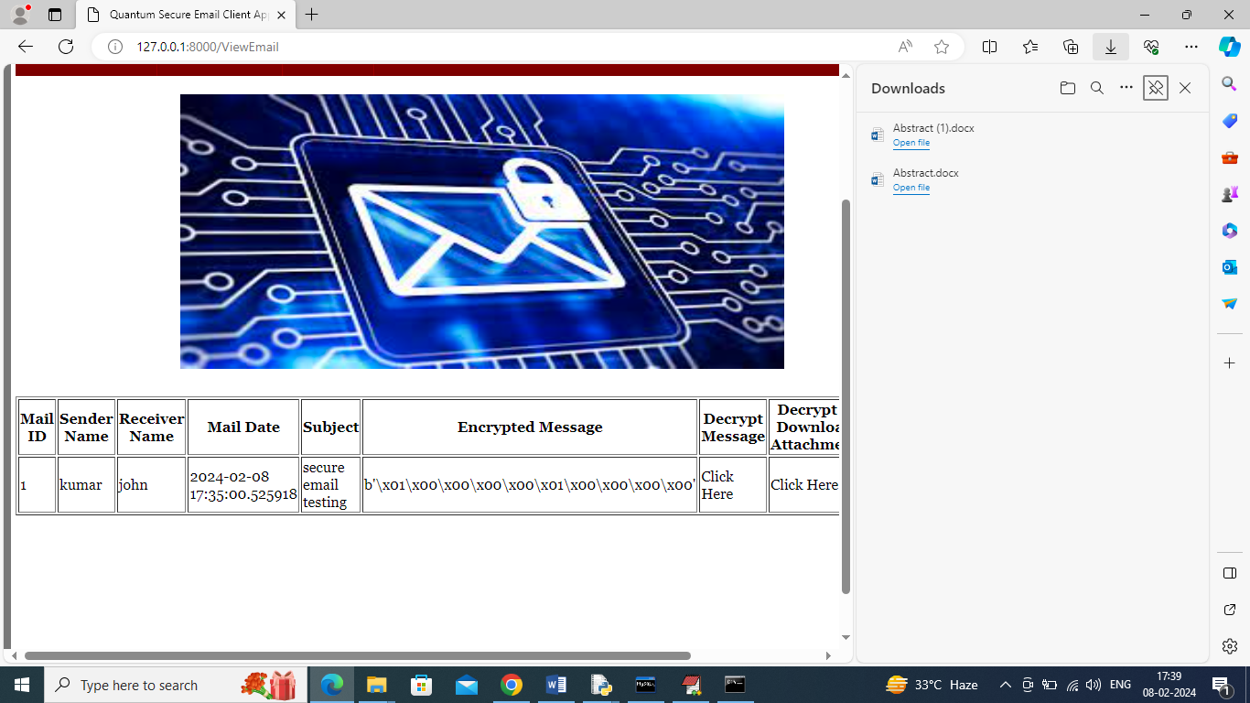

In above screen after clicking on second ‘Click Here’ link we can see attached file decrypted and downloaded to download folder.

Similarly by following above screens you can send secure mails from sender to receiver